API TESTING
DOCUMENTATION
Category & Product Management
━━━━━━━━━━━━━━━━━━━━━━━━━━━━
SUBMITTED BY
Fazila Fatima
[Student1601187 / 2408B3]
TOOL USED: POSTMAN

Category Get
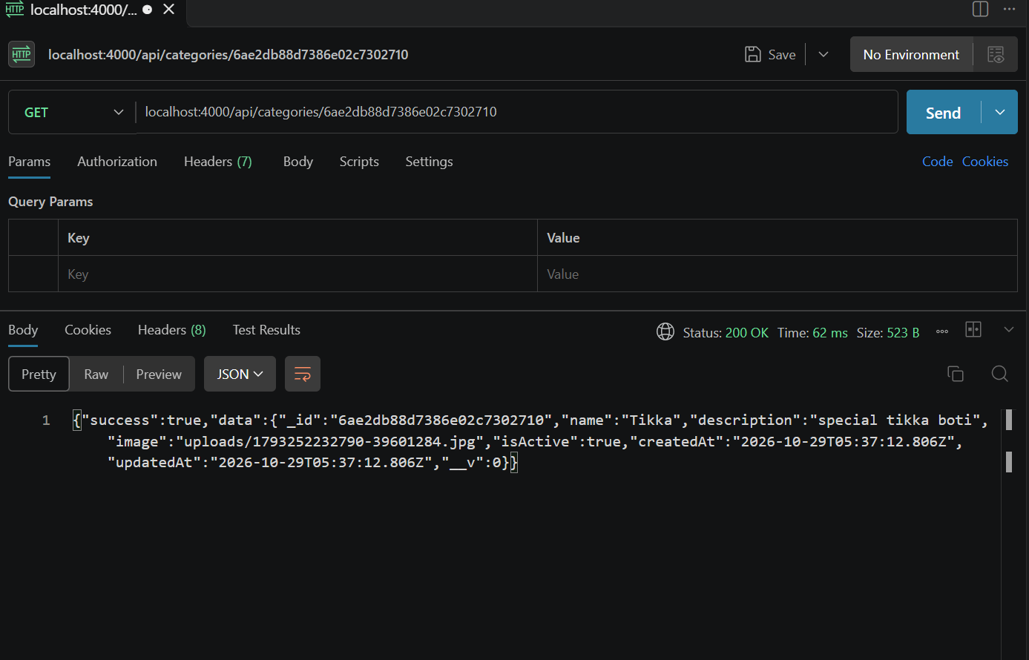

Product Get
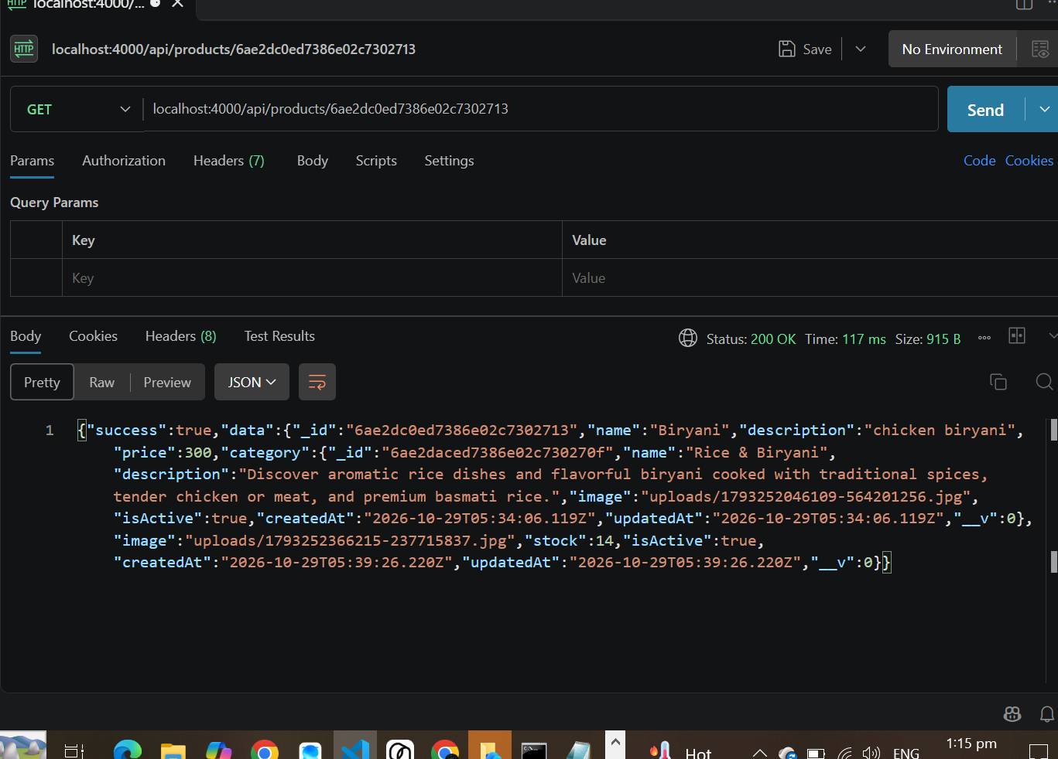

Category Create
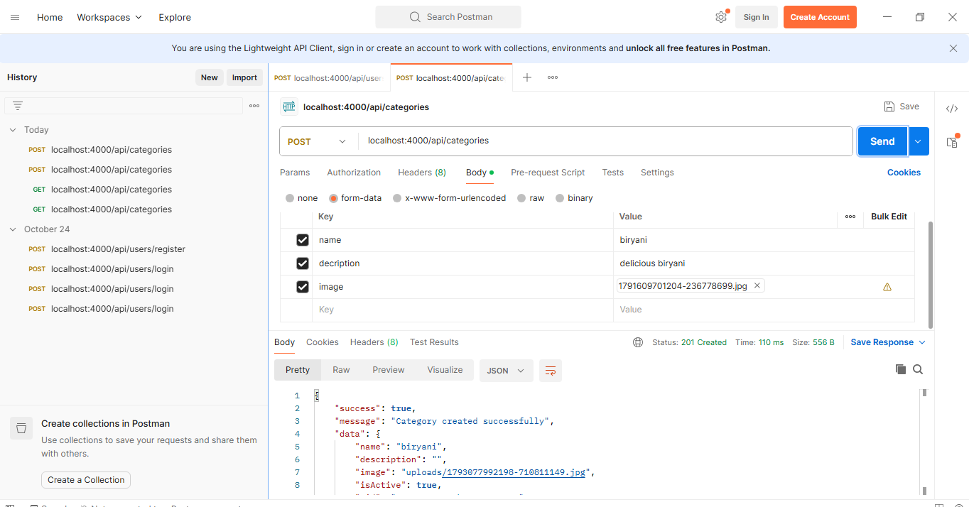
Product Create
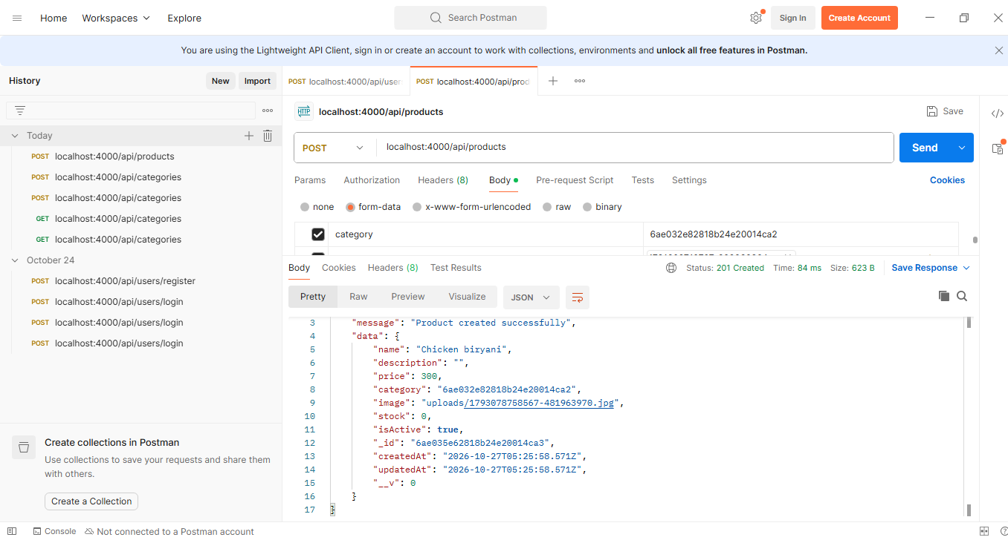
Category Delete
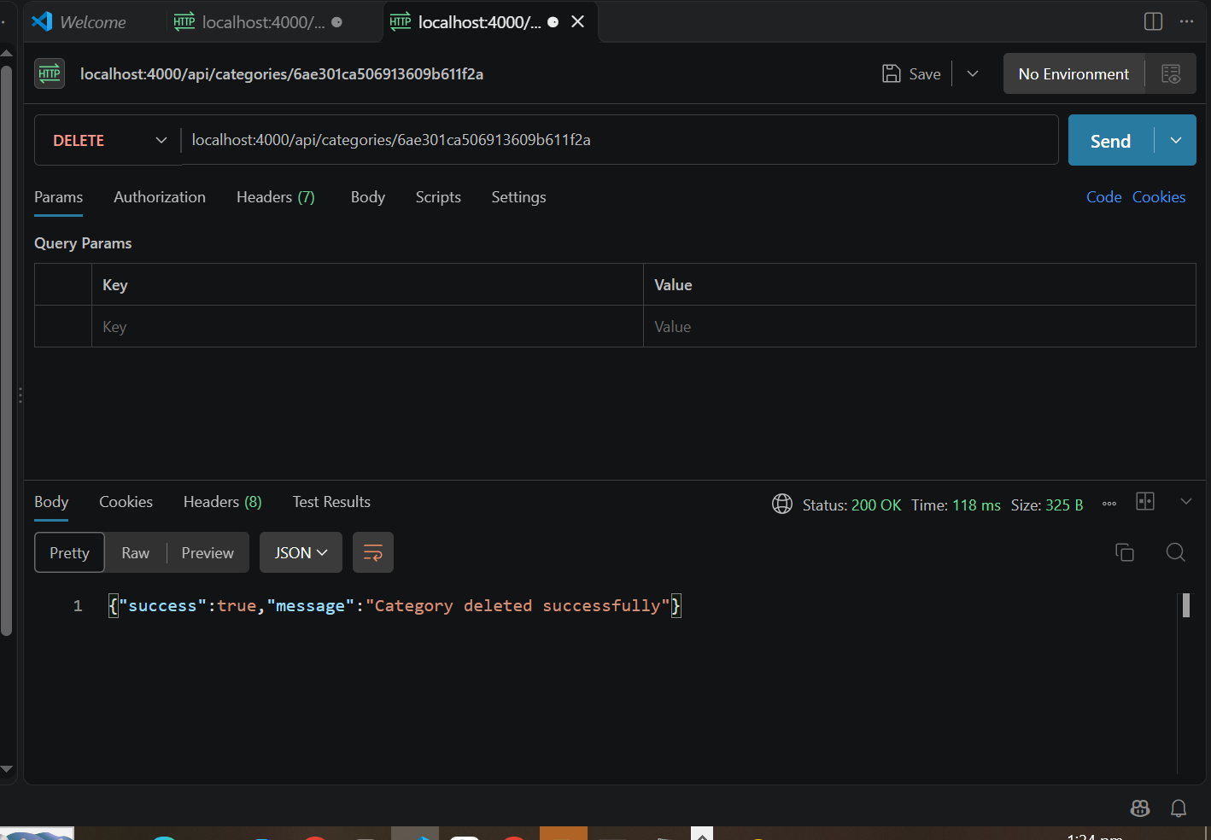
Product Delete
